**Fungi, herbivores and predators have an impact on secondary succession of a tropical rainforest vegetation**

Piotr Szefer1,2, Kenneth Molem3, Austin Sau3, and Vojtech Novotny1,2

1 Faculty of Science, University of South Bohemia, Branišovská 31, 370-05 České Budějovice, Czech Republic.

2 Institute of Entomology, Biology Centre, Czech Academy of Sciences, České Budějovice, Czech Republic

3 New Guinea Binatang Research Center, Madang, Papua New Guinea

**Key Words**: secondary forest, tropics, Papua New Guinea, insect herbivory, pathogenic fungi, predator exclosures, successional dynamics, top down factors, food webs.

**Abstract**

1. Successional theory emphasizes plant performance and competitive ability as key drivers of early successional dynamics, in contrast to top-down biotic factors maintaining plant diversity in mature tropical forests.

2. Here we are testing, for the first time, the effects of food web interactions on the early successional dynamics in a lowland tropical forest in Papua New Guinea. On 36 vegetation plots (25 sq. meters) we experimentally manipulated insect herbivores, fungal pathogens and predators on replicated 5x5 m successional plots using broad spectrum insecticides, fungicides, predator exclosures and herbivore introductions.

3. Experimental food web manipulation had complex effects on the plant community during one year of succession. Herbivorous insects increased species richness, evenness, and Shannon diversity of plant community and its species composition, but they decreased was species richness of woody plants. Fungi increased species richness and abundance of woody plant communities. We also found evidence for the top-down effects of predators, but only on the evenness of woody plant communities. Insect herbivores and predators, but not fungi, also increased the predictability of successional trajectories in plant communities.

*4. Synthesis*. Food webs have clear but complicated impact on the direction and predictability of the early secondary successional trajectories in rainforest ecosystems. Diverse modes of action of individual biotic factors (pathogens, herbivores and their predators) complement each other and affect different aspects of the woody plant community, generally contributing to high plant diversity in the early succession.

**Introduction**

Ecological succession is one of the few complex, community-level processes that are underpinned by ecological theory allowing us to predict, to some extent, its trajectory, both in terms of species composition and species traits of secondary vs. primary forest species (Turner 2001).

Deterministic, rule based succession is believed to be driven mainly by interspecific competition and environmental filtering (van Breugel et al. 2012, Asefa et al 2017, Craven et al. 2018). Forest regeneration patterns are thus hypothesized to be mainly shaped by plant traits and abiotic conditions (Yamamoto 2000, Schnitzer & Bongers 2002), while the effect of top-down biotic interactions is rarely considered.

This situation is in sharp contrast with increasing attention paid to top-down control of plant composition in primary tropical forest. The Janzen-Connell hypothesis suggest that diversity of these forests could be maintained by the density-dependent mortality by plant pathogens and herbivores (Janzen 1970, Connell 1971). In tropical forests herbivorous insects (Gillet 1962), their predators (Richards & Coley 2007) and pathogenic fungi (Augspurger 1983, Clark and Clark 1989) are ubiquitous, abundant and are known to have the ability to affect plant population dynamics and ecosystem processes (Crawley 1989). Recent manipulative experiments in Neotropical old-growth forest have shown that pathogenic fungi, acting at the seedling stage, are important density-dependent mortality agents. Herbivorous insects were also important mortality factors, but they caused seedling mortality independent of their density (Bagchi et al 2010, 2014).

To our knowledge there are no studies extending these experiments to the effects of predators despite the fact that the importance of trophic cascades is well recognized in tropical forests (Letourneau et al 1998, Milton and Kaspari 2007, Leles et al. 2017).

Early successional communities assemble under specific ecological conditions: they arise as a result of unpredictable disturbance and for a short period of time offer environment with high light intensity, often also high mineral resources, and free from competition by other plants. This leads to environmental filtering for pioneer plant species with species traits maximizing dispersal and growth rate at the expense of anti-herbivore defenses (Coley et al. 1985, Denslow 1987, Herms & Mattson 1992). The resulting species pool of early successional species is relatively small and more closely related phylogenetically than expected by chance (Norden 2009, Whitfeld et al. 2012).

The potential for plant-herbivore interactions having impact on early successional vegetation is significant. Herbivorous insects are more abundant on secondary than primary forest vegetation because secondary vegetation has higher abundance of palatable and poorly defended young foliage (Lepš et al. 2001, Whitfeld et al. 2012). Species-rich secondary vegetation genera including Ficus and Macaranga have rich herbivorous communities in PNG (Novotný et al 2002). Mobile natural enemies, like bats and bird, tend to follow more abundant prey into the canopy gaps (Richards & Coley 2007). Fungi on the other hand had higher infection rates in shade tolerant species (García-Guzmán & Heil 2014). Importantly, the impact of pathogens, herbivores, or predators of herbivores on plants cannot be inferred solely from the frequency of trophic interactions. For instance, high herbivory could be compensated by fast growing pioneer species, but not slow-growing primary forest species (Trumble et al 1993, Strauss and Agrawal 1999). Particularly in highly productive ecosystems bottom-up control is usually strong (Scherber et al. 2010, Zhang & Adams 2011). Manipulative experiments are therefore key approach to assessing the importance of top-down biotic information on plants.

Environmental filtering shapes the structure of functional trait composition in tropical forests (Asefa et al. 2017). . Specific leaf area (SLA) tends to decrease and leaf dry-matter content (LDMC) increase in the course of secondary succession (Buzzard et al. 2015, Boukili & Chazdon 2016). High community weighted mean (CWM) SLA values and low LDMC values often indicate low competitive pressure within the community (Kunstler et al. 2016). So far, these traits have been evaluated in terms of their performance in plant competition, (Lasky et al. 2014), but the impact of plant-based food webs on the functional trait composition in plant communities has not been examined.

Even low variability in environmental conditions often leads to alternative, divergent successional pathways (Mesquita et al. 2001, Suding et al. 2004, Williamson et al. 2012). These trajectories differ significantly in community structure (Norden et al. 2015), species composition (Guariguata & Ostertag 2001, Barlow et al. 2007) and species turnover rates (Mesquita et al. 2015), therefore, making prediction of successional outcome a challenging task. The unpredictability is assigned to random, neutral dynamics (Hubbel 2001) including colonization, extinction and ecological drift. Some of these random changes in the structure of early successional plant communities may persist for decades (Saldarriaga et al. 1988).

In this paper we test experimentally the general hypothesis that above-ground biotic factors: fungal pathogens, insect herbivores and predators of these herbivores significantly affect initial secondary succession of tropical rainforest vegetation and potentially alter its successional trajectory. More specifically, we hypothesise thatherbivores control productivity, richness and composition of plant community in early succession through a frequency-dependent feeding, which has stabilizing effects on the community (Chesson 2000). The removal of insects should lead to higher plant biomass, and decreased plant species richness, diversity and evenness resulting in a simplified community composition. Experimentally increased generalist herbivory should have the opposite effect. Freckleton and Lewis (2006) argued that generalist natural enemies, acting on the whole community biomass are not able to cause the density dependent effects. However, Terborgh (2012) presented evidence for generalist herbivores having diversity enhancing effect on the plant community. High intensity of feeding by generalist herbivores can also lead to simplification of the community with low biomass, richness and diversity as it might lead to high dominance of a few unpalatable species (Kempel et al. 2015). We hypothesize that suppressed herbivorous insects abundance will result in higher LDMC values in the community, whereas under strong pressure of herbivores plants will overcompensate, resulting in higher CWM SLA values. . Contrarily predators should have d.We predict no or weak effects of fungi on the plant communities considering unfavourable microclimatic conditions for fungi in early successional stages, but consider this experiment important in the view of their importance in primary forests. Finally we hypothesize (5) that the biotic factors, by responding to the initial plant composition, determined mostly by dispersal, in predictable manner, increase predictability of succession trajectories. by increasing determinism during community assembly process.

**Materials and methods**

*Study sites*

The experiment was conducted in tropical rainforest surrounding the Wanang vilage (145°5′32″E, 5°14′26″S) located in the Wanang Conservation Area in the Ramu River basin, Madang Province, Papua New Guinea. The climate in the region is humid, with a mild dry season from July to September. Annual rainfall averages at around 3500 mm and mean monthly temperature is 26°C (McAlpine et al. 1983). The study was conducted in abandoned food gardens created during slash-and-burn subsistence agriculture within the primary forest matrix. Abandoned gardens originate from forest patches cleared for cultivation. The cleared vegetation is for burned, gardnes planted with mixed crops and after a few harvestsm typically after two years, the gardens are abandoned and left to spontaneous forest regeneration, creating thus an excellent opportunity to study secondary succession. No tillage, pesticides or fertilizers are used during cultivation, and the soil properties and nutrient content are not affected by the agricultural process (Kukla et al. in press). The abandoned gardens have open canopy and mostly undisturbed seed bank, required for a secondary growth to initiate. The forest regeneration follows the same trajectory as that in the nearby natural forest tree gaps (pers. obs.).

*Experimental design*

Within the radius of three km from the center of the village we selected six experimental blocks (gardens) 3-5 years old, each covering an area of approximately 400 m2, with minimal distance of 200 m between blocks. Within each block we cleared all aboveground vegetation and removed all the rocks and dead wood in order to keep exposed bare soil in >95% of the plot area. We also removed all tree stumps and tree roots from top 30 cm of soil to prevent resprouting. These initial preparations should not have an effect on the seed bank and soil conditions (Chazdon 2014). Within each block six 5x5 m experimental plots were established, resulting in 36 experimental plots (6 plots x 6 blocks). We separated the plots by at least one meter and established also three meter cleared margins around the block to minimize edge effects. Control plot and five experimental treatments were randomly assigned to plots within each block according to the randomized complete block (RCB) design. Following treatments were applied continuously for 12 months:

1. Exclusion of pathogenic fungi (F). To reduce infections by wide range of fungal pathogens, contact fungicide mancozeb (12.5 g soluble powder per 5l, commercial name: Mancozeb) was applied on above ground plants according to manufacturer’s instructions at weekly intervals. The plot was surrounded by a 0.5 m high dummy plastic fence with a gap left at the ground level to allow easy access to insect herbivores, lizards and rodents, in order to simulate possible effect of fencing used in I, P, H1 and H2 treatments (see below) on plants.

2. Herbivorous insect exclusion (I). To achieve both systemic and non-systemic protection we applied two types of broad spectrum insecticides: lambda cychalothrin (5 ml per 5l, commercial name: Thunder) and imidacloprid (1.5ml per 5l**,** commercial name: Mustang). Because of intensive vegetation growth insecticide applications were repeated every week according to the manufacturer’s instructions. The plot was surrounded by a 50 cm high plastic fence that continued 20 cm below the ground. Insect glue (tanglefoot) was repeatedly applied on the top of the fence. The fence prevented colonization by crawling insects.

3. Control (C) and was sprayed weekly with appropriate amount of water. A dummy fence was used as in F.

4. Exclusion of predatory ants, insectivorous birds, and bats (P). Transparent fishing net (1.5-2.0 cm mesh size) was secured over the plot to protect vegetation from foraging birds and bats. Further, we used poisonous tuna baits (Permethrin 0.5%) exposed inside the plot in monthly intervals to reduce ants as key insect predators. The plot was surrounded by the plastic fence as in I to prevent ants from invading the plot.

5. Increased herbivory – moderate (H1). We used locally common, highly polyphagous and flightless *Oribius* sp. weevils to increase herbivory pressure within the plot. Weevils from this genus were previously documented from the local secondary vegetation and their wide polyphagy was established by feeding tests (Supplementary Information) . Every two weeks, 25 weevils per plot were collected in surrounding forest, starved for 24 hours and released into the plot to sustain high population size of weevils. These plots were additionally protected from predators with exclosures (see P), and fenced with insect glue applied on the top of the fence to prevent weevils from dispersing.

6. Increased herbivory – high (H2). The same treatment was applied as above but with 125 *Oribius* sp. weevils per plot introduced every two weeks.

*Sampling*

After 12 months of undisturbed growth complete above ground vegetation from all 36 plots was destructively sampled. At each plot all plant species were sorted and identified to species and weighed with 1 g accuracy. During sampling we also counted and measured all the stems with diameter at breast height (DBH) ≥1cm. We calculated leaf area by randomly picking leaves from a pool of all available leaves for a given species at a given plot until we filled a 50x50 cm area (“leaf frame”) with leaves that was photographed and processed using ImageJ software (Schneider et al. 2012) to obtain complete leaf area and its estimated loss due to herbivory. The leaf samples were then oven dried, weighted and leaf dry matter content (LDMC) was estimated. We obtained measurements of specific leaf area (SLA) by dividing leaf area by its dry mass. We always use community community-weighted means (CWM) for LDMC and SLA values, where each species is weighted by its biomass. Herbivory was expressed as the proportion of the leaf area consumed by herbivores.

*Data analysis*

We used linear mixed models with block (garden) taken as a random factor, to compare different community descriptors of our treatment plots to the control *We fitted our models in a Bayesian framework* using Hamiltonian Monte Carlo sampler in STAN implemented in brm function from *brms* package (Bürkner 2017) in R (R Development Team, 2016). We performed additional post-hoc comparisons using the posterior distributions using 2.5% and 97.5% quantiles. We reported (… I need to decide what… R2, AIC, explained deviance). Values of herbivory and LDMC were logit transformed, and SLA log transformed prior to the analyses to obtain Gaussian error distributions. In case of number of species and number of stems per plot residuals were modeled using Poisson distrubution, where we also tested for overdispersion in residuals.

To test if our treatments significantly affected community composition we used RDA ordination, conditioned on block implemented in vegan package (Oksanen et al. 2016). Significance of differences were assessed by permutation tests (999 randomizations) preserving the random structure of blocks determined by the experimental design. Because of differences in local abundances of species between locations we standardized plant composition samples by total abundance within the plot.

To determine if the relative importance of random and deterministic processes during community assembly was affected by our treatments we used null model approach proposed by Chase et al. (2011), initially modified by Stegen et al. (2013) and further by Alberti et al. (2017) to account for species abundance. In our case we adapted this procedure to species’ biomass instead of number of individuals. We also modified previous approaches by constraining for each randomization our dataset only to control plots and one treatment plot, so that experimental communities (30 plots vs 6 control plots) would not be over-represented in the randomization procedure. Therefore, in each procedure we subsetted full community dataset to 12 plots (six control plots and six treatment plots) for each of the five different comparisons between control plot and experimental treatments. For any given pair of plots both plant communities were randomly assembled using following constraints: **(1) For a given plot the number of species and total biomass in randomly assembled community war restricted to the observed (empirical) ones. (2) Probability of sampling given species was calculated based on occurence frequencies in all plots (sum of ocurrences within a plot across all 12 plots for a given pair of control and treatment blocks) for a given pair of treatments. To randomly assembly a community instead of individuals we were sampling units of biomass equal to 1g, the lowest biomass measured in our plots. (3) Cumulative biomass for a given plot was set to be equal to the empirical biomass collected from that plot and (4) the probability of increasing biomass of a given species in a community by one unit was proportional to the relative biomass of that speciess accros all 12 plots for a given control and treatment combination. For each pair of plots random assembly process was reapeated 999 times and at each randomization Bray-Curtis (BC) dissimilarity of randomized communities was calculated to quantify compositional turnover. These randomized BC values were then compared to the empirically observed dissimilarity values for a given pair of plots. Next we calculated the proportion of iterations, where the BC index was smaller or equal to its empirical value. To obtain Raup–Crick index (Chase et al. 2011) we subtracted 0.5 from that proportion and divided this difference by two, so that it ranges from a negative one to one.** This index has a useful interpretation as it indicates whether a pair of plots is less similar, or as similar as the community composition expected by chance. It therefore can be used to measures importance of deterministic processes in community assembly process and values close to negative one show that community is assembled in a deterministic and convergent fassion, whereas values of RC close to 1 are driven also by deterministic but divergent processes. By following procedure developed in Alberti et al. (2017), we tested if treatments had an effect on community assembly process using linear mixed models. We setan average Raup-Crick value for any comparison of that plot with all the other plots of the same treatment to be the response (five comparisons for each replicated treatment, i.e.: 1 vs. 2, 1vs 3, 1 vs. 4, 1 vs. 5, 1 vs. 6). We used treatment as a fixed effect, block as a random effect and performed our analysis using *lmer* function as described above and we used likelihood ratios to test the significant differences between the control and treatment plots.

**Results**

After one year of regrowth, the vegetation across all experimental plots comprised 96 plant species (Table S1), including 40 woody species. Most abundant species included: . Average biomass collected from a single experimental plot: …. .Individual blocks differed in their plant composition with an average Bray-Curtis dissimilarity between control plots was 0.52 (min-max) for the whole above-ground community and 0.45 for the woody species communities. One plot treated with insecticide was an outlier overgrown by a vine *Calopogonium mucunoides* Desv. (72% of the total biomass of the plot). This plot was removed from the analyses (but we not where the results would change if included)*.*

The effects of individual treatments often changed between all vegetation and woody plant (Table 1). The fungicide treatment (F) decreased stem density of woody plants (z-value = -5.202, P < 0.001) and showed a marginally significant tendency to decrease species richness of woody plant species (z-value = -1.701, P = 0.089). Insecticide (I) treated plots had lower number of species per plot (T = -2.046, P = 0.041) and lower diversity measured by Shannon’s H’ (T value = -2.543, P = 0.018) in the whole plant community. For the tree communities the same patterns for species richness and diversity were visible, but only marginally significant (P = 0.089 and 0.062 respectively). Lower average evenness for the whole community was only marginally significant (T value = -2.002, P = 0.056) and there was no strong evidence for the same effect in the woody plant community. The plots protected from predators (P) had a lower number of stems (Z value = -3.398, P = 0.001) and there was some, marginally significant, evidence for higher evenness (T value = 1.841, P = 0.078) for woody plants communities. Low herbivory increase (H1) caused marginally significant decrease in diversity (T value = -1.923, P = 0.066) and evenness (T value = -1.829, P = 0.079) for the whole community. High herbivory increase (H2) was the only treatment to decrease the plant biomass both in the whole community and the woody plants (T value = -3.389, P = 0.002 and T value = -3.077, P = 0.005 respectively). Herbivores at the high abundance also significantly reduced the number of stems per plot (T value = -6.707, P < 0.001).

The insecticide treatment (I) altered the species composition of the entire vegetation and the woody plant community (Fig 2., permutation test, F=2.828, P = 0.011 and F = 2.892, P = 0.023 respectively). High herbivory pressure (H2) had an effect opposite to the insecticide treatment and was marginally significant only for the full community (F = 2.017, P = 0.052). Differences in the community composition were driven by only a few species of woody plants, measured as their partial contribution to the total variance. These were: *Melochia sp. 1* (6% the whole community, 7.3% only for woody plants)showing strong preference to the moderately increased herbivory treatment; *Pipturus argenteus* (G.Forster) Wedd (4.5% and 6.3%) wasmost abundant at the insecticide treatment plots; *Trema orientalis xxx* (1.1% and 3.9%) showed a positive reaction to the fungicide treatmentand *Melanolepis multiglandulosa* (Reinw. ex Bl.) Reichb.f. & Zoll. (1.3% and 0.8 %) was most abundant on the plots with increased herbivory.

The insecticide treatment had a marginally significant decrease in SLA and increase in LDMC (T value = -1.970, P = 0.060, T value = 2.481 and P = 0.020 respectively). Similar pattern for LDMC was observed for the woody plant species community (T value = 2.168, P = 0.040). Woody plants showed evidence for higher herbivory damage on plots protected from predators (P) and on the plots with high herbivory pressure (H2) (T value = 2.421, P = 0.023 and T value = 2.395, P = 0.023 respectively) (Fig. 3).

The RC dissimilarity values among the control plots showed highly variable, but non-random composition (Fig. 4). When these values were compared with RC dissimilarity within plots for each treatment, none of the treatment had an effect on the entire community, but the insecticide treatment (χ2 = 3.892, P = 0.048) and predator exclusion (χ2 = 4.923, P = 0.026) significantly decreased within treatment dissimilarity and increased randomness of community assembly (mean RC index values closer to zero) for woody plants (Fig. 4).

**Discussion**

Our study revealed that biotic top-down factors, including the effects of invertebrate herbivores, their predators (birds, bats and ants) and fungal pathogens of plants, influence early successional trajectory of secondary rainforest vegetation in lowland Papua New Guinea

Our hypothesis that herbivorous insects control biomass, species richness and diversity of plant community, was partially supported by our results. Our experimental application of insecticide had, similarly to the results from the primary forest (Bagchi et al. 2014), strong effect on the plant community composition resulting in simplified structure with only few distinct dominants (Supplementary Information, Fig. S1). This shift in community structure was driven mainly by high dominance of *Melanolepis multiglandulosa*, together with decreased abundance of *Pipturus argenteus*. Kempel et al. (2015) argued that the preferences of invertebrate herbivores can drive the change in community composition. In our experiments *P. argenteus* suffered greater herbivory across control plots than *M. multiglandulosa* ([t test?] Supplementary Information, Fig. S4) and our previous studies also showed that herbivorous insects preferred *P. argenteus* (Basset 1996) over *M. multiglandulosa* (Novotny et al. 2004). Insecticide treatment was also responsible for decreased richness, diversity and evenness of our experimental plant communities, which is in agreement with majority of large herbivore exclusion experiments from temperate grasslands (Stein et al. 2010, Mortensen et al. 2017, Jia et al. 2018). The mechanism responsible for these patterns has been proposed by Agrawal et al. (2012). He showed that when herbivores were removed, plant competition intensified and led to higher dominance of a few competitively superior plant species. We found support for this explanation in CWM trait patterns which we will discuss later. However, we found little evidence for similar effects on species richness and evenness in pioneer woody plant communities. It is possible the length of experiment was too short for the effects to materialize.

Somewhat unexpectedly, herbivore removal had no effect on stem density or biomass. Herbivore removal experiments in the tropics usually result in higher biomass and abundance of plants (Jia et al. 2018). However, successional theory predicts such outcome for pioneer stages of the vegetation where plant species maximize growth in competition for light and, in accordance with resource availability hypothesis (Coley et al. 1985), they can compensate for biomass loss due to herbivores (Maron et al. 2014).

[I have a problem discussing H1 and H2 treatments] Artificially increased high herbivory pressure (H2) showed some evidence for density dependent feeding (Fig S3). However, this trend was not clear for the tree species and vanished completely at the intermediate level of herbivore increase. Nonetheless, despite the increased herbiovory damage on trees, H2 treatment had no effect on richness, diversity nor evenness. This may confirm results of simulations performed by Freckleton and Lewis (2006) which showed that density dependence caused by generalist natural enemies acting through total community density, as opposed to individual species density, would not affects richness, diversity and evenness. We show here that this might be true at least for insect herbivores in the pioneer tree comunities in the tropics with H1 having low and H2 high impact on biomass and abundance. Nevertheless, it is difficult to explain decreased richness and evenness of the whole community on H1 plots. Predictably, artificially increased herbivory led to lower biomass, lower stem density and higher herbivory in woody plants, although only for the high level of additional herbivore. Interestingly, this large structural change did not generate changes in species richness, diversity and evenness. Moreover, because plots with artificially increased herbivory were also protected from predators *Oribius* sp. beetles would have to compete with abundant large bodied herbivores for resources. Increased abundance of *Oribius* sp. certainly had a disruptive effects on the interaction network, which did not affect plant community characteristics significantly. Thus, complementarity of various herbivorous species host preferences, competitive hierarchy and herbivore-plant network structure driven by plant traits and herbivores’ preferences might be important as in our data high abundance of *Oribius* sp. caused shift in plant community structure which resulted in increased abundance of *M. multiglandulosa* which was otherwise losing in competition with *P. argentaus* on insecticide treated plots (Fig. 2), whereas *Melochia* sp. was dominant on H1 plots.

We found evidence for the top-down effects of predators on plot biomass. As discussed in review by Mooney et al. (2010) effects of vertebrate predators on plant communities are stronger, whenever predaceous arthropods are abundant and there is a strong intra-guild predation. This might be the case here, as we found average 37.7% decrease in biomass without predators against the reported 14%, and intermediate predaceous arthropods are represented by spiders and mantids. However, decrease in plant biomass was only marginally significant and that effect was not present in the woody plant community. Hart (2002) argued, that the strong pressure of intermediate level predators may dampen the effects of top predators. Spiders and mantids, which are a frequent component of predatory birds and bat diets, would increase in abundance in plots protected with exclosures and potentially regulate herbivore populations, which in turn can diminish their effect on plant productivity (Finke & Denno 2005). The lack of effects on plant biomass from the focal predators that partially reduce herbivores is not surprising considering that even the complete removal of insect herbivores in the insecticide treatment did not have such effect. Another possible explanation is that the high abilities of pioneer trees to compensate for herbivory damage, as well as higher abundance of species least attractive to herbivores (e.g. *M. multiglandulosa*, Fig. S4), may cause biomasses of experimental communities not to differ greatly from those in the control plots. Moreover, Schmitz et al. (2000) argued that top-down effects of predators are more likely to be present in communities where plants have anti-herbivore defences. In our experiment, even though some level of variation in herbivore defences can be observed, in general we would not expect them to be strong (Kardol et al 2006, Lasky et al. 2014). Decrease in biomass in plots without predators was followed by increase in community evenness. Jia et al. (2018) found that similar pattern might be caused by density/frequency dependent feeding of generalist herbivores. Tentative exploration of this pattern in our data showed that species most abundant in the control plots were also the ones suffering highest biomass losses in plots, where predators were removed (Supplementary Information, Fig. S2 and S3 [i should make one graph with two regression lines]). Higher evenness together with lower number of stems and slight biomass increase in tree communities as a response to the removal of predators could be a result of a change in size structure of herbivores (Singer et al. 2017). Change in the size structure can potentially increase evenness in herbivore community (Magurran et al. 2013), which may cascade down also onto their host plants, as larger insects tend to feed on broader range of host plants (Davis et al 2012). Large bodied herbivorous insects might also be more exploitative on plants. This should, in turn, result in decreased productivity on experimental plots. Nonetheless, because of the high energetic efficiency of bigger sized insects, they not necesserily significantly reduce plant biomass or abundance (Schneider et al. 2016).

Pathogenic fungi did not affect the community composition, which confirms our predictions on weaker effects of pathogenic fungi early in the succession. However, we found some evidence for the richness enhancing effect of fungal pathogens in pioneer tree community. Fungal pathogens can drive species turnover through accumulation of host specific pathogens in time (Kardol et al. 2006). For example Mangan et al. (2010) showed that old-growth forest dynamics are driven by plants-soil feedbacks mediated by pathogenic fungi. This may suggest that stronger effects of fungal pathogens can be expected later in the succession, where there are more mature leaves and environmental conditions facilitating fungal infections (Marquis et al. 2001). Effect of pathogenic fungi on community richness might not be noticable also in the situation where dominant pathogens are generalists (Freckleton & Lewis 2006), which is a safe prediction for an early successional plant communities (Koziol & Bever 2016) as specialists usually accumulate in the community later (Pandit et al. 2009, Novotny et al. 2010). Low host specificity of pathogenic fungi might be the case in our experiment as we found that fungicide application decreased significantly the number of stems within the plot, similarly to predator exclusion (P) and generalist herbivore (H2) treatments, where increased abundances of generalist herbivores are assumed to take place.

The effects of herbivory and fungal pathogen infections are rarely examined with respect to changes in plant trait distribution in plant communities. . The low SLA and high LDMC are characteristic of the plant communities driven by strong interspecific competition (Kunstler et al. 2016). We expected plant competition to intensify in the absence of herbivores, leading to higher SLA and lower LDMC values. Further, we expected the plant species with high SLA and low LDMC, usually palatable to herbivores, increasing when freed from herbivore pressure. Surprisingly, we observed SLA and LDMC values in the opposite direction xxxx

RC values at the control plots revealed that species composition of the communities showed higher than random variability between sites (divergent but deterministic community composition). This result confirms predictions that in highly productive plant communities growing in nutrient rich environment would show deterministic but divergent assembly processes due to priority effects (Chase and Liebold 2002, Chalcraft et al 2004, Chase 2010). The RC values for communities without herbivores and with predators excluded were closer to zero, similarly as in herbivore exclosures from grassland communities (Alberti et al. 2017). More random community assembly with suppressed herbivores might be caused by enhanced effect of random colonization of the plots by plant species. . Predator exclusion, , we would expect that more random assembly would be a result of some effects cascading down to herbivore communities. Chase et al. (2009) argued that abundant consumers, in our case herbivorous insects, can increase stochasticity during community assembly process through by decreasing number of individuals in the community, and boost their chance of local extinction. We found partial support for this hypothesis in our data, where we observed lower number of stems in plots without predators. Evenness was affected positively, which would suggest rare species being removed from the community, but the 23.94 % average richness decrease was not significant. However, at majority of the plots, from which predators were exclude, lower number of species was observed (Fig. 1). It is therefore possible that the lack of significance might be caused by low statistical power of our tests. Surprisingly fungicide treatment did not increase randomness of the community assembly processes, despite their negative effect on tree richness and stem density. Low richness can simply be a result of decreased number of stems on the plot. This pattern is rather unexpected to observe if fungal pathogens are actually main mortality factor in the early stages of succession. Mordecai (2011) presented two hypotheses of pathogenic fungi diversity promoting mechanisms, which would produce similar patterns to the ones observed in our data: (1) reduction of fitness differences between pioneer trees and (2) changing the competitive structure between species. Second explanation is less probable as it should also result in significant and consistent changes in plant community structure. Therefore, we conclude that pathogenic fungi promote richness through differential effects on dominant plant species, where abundant species experience negative feedback, and rare species are positively affected or are neutral to fungal infections. Additionally, fungal infection can change herbivore preferences and performance on infected plants (Fernandez-Conradi et al. 2018), which introduces another level of complexity to fungi-plant-herbivore interactions.

In this study we tried to explore possible mechanisms, through which pathogenic fungi, insect herbivores and predators are shaping community composition of early successional tropical rain forests. Interestingly, removal of each single biotic factor affected different aspects of the pioneer tree community. A natural step forward would be to study these biotic factors in combination to identify possible complementary effects on plant composition and succession. Moreover, to get deeper insight into mechanisms at place and to validate above-stated hypotheses additional information on seed rain, mortality of newly established seedlings in the route of succession would have to be collected. Demographic data together with host preferences of natural enemies would help to shed some light on the processes involved, and better understand secondary succession in tropical forests.

Despite our considerable effort we few pitfalls regarding our methods were identified. Our evaluation of the ant abundance performed on the ground, did not show significant decrease in predator exclusion plots compared with the control. However, during plant sampling we generally observed low abundance of small sized, non-predatory canopy ants. In case of a fungicide used we should also note, that the active ingredient of our fungicide (mancozeb) has been also used previously (Bagchi et al 2014) and it didn’t show ability to remove density-dependent effect in seedlings communities in primary forest, therefore if fungi related density-dependent effects were present at the initial stages of succession we probably were not able to remove them. Important side effect ot mancozeb is that it can accumulate in soil and may have negative effects on ammonification and nitrification (Walia et al 2014). However we expected that these undesirable effect of mancozeb would be minimized due to short half-life times (Xu 2000) and easy biodegradability in tropical soil conditions (Racke et al 1997). Also netting used to build exclosure might have boosted web building spiders abundances in an addition to the general increase of arachnids abundance under their natural enemies suppression. Exclosure frames might provide base for building webs by spiders, which were not sampled when exclosures were removed. Number of blocks used for the experiments was limited by suitable locations available and our abilities to maintain and sample them. Nevertheless, as mentioned before some effects may have not been detected and increased sample size could result in higher statistical power of our tests.

Our results point out on an important role of local scale interaction web of pathogenic fungi, predators and herbivorous insects for an initial successional processes and for shaping future community composition. It also provides potential factors which can be used to decrease the high unpredictability of successional trajectories found in empirical data. All the elements are connected and create an interdependent network. Therefore in a disrupted, simplified ecosystem all of its biotic interactions will be affected. From our results we can conclude that without a rich network of consumerssuccessful regeneration of plant communities may be inhibited and importance of random contingent effects during assembly processes increase. Our results show that in tropics biotic factors have the ability to change the competitive structure within regenerating communities, resulting in secondary effects on the community composition. Secondary succession is a dynamic process where driving factors can also change with time and successional stage. For the understudied initial succession of tropical rain forest we found various complex effects of biotic factors involved and having potential to affect later stages of succession, form which herbivorous insects however, turned out to control major characteristics of the stucture and diversity. However, effects of pathogenic fungi can gain on importance later in the succession, when the canopy formation would dominate. We need more studies focused on collecting detailed demographical data combined with information on individual species competitive abilities and functional traits, including soil biota, all tested in greenhouse experiments would allow for better understanding of exact mechanisms of biotic control of successional communities and possibly in the future better understand how can we facilitate more effective regeneration of tropical forests.

**Acknowledgments**

Tereza Holicova for processing leaf frames data. Jan Leps, Juan Alberti and Leonardo Re Jorge for useful discussions, Binatang Rerearch Center staff in Papua New Guinea for support during field work. Grants: GACR 17-23862S and the ERC grant 669609 to VN

**Authors’ contribution**

VN and PS conceived the ideas and designed methodology; KM, AS and PS managed experiments and collected the data; KM identified plants; PS analysed the data and led the writing of the manuscript. All authors contributed critically to the drafts and gave final approval for publication.

**References**

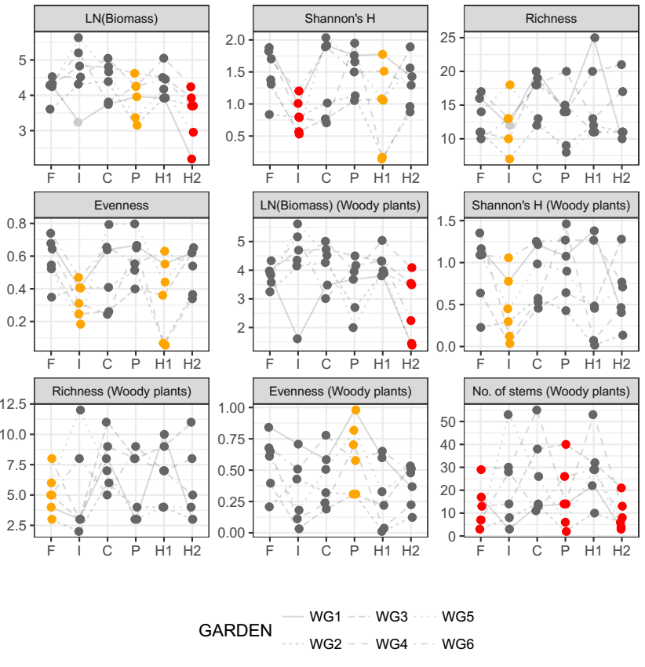

Figure 1. Community descriptors based on all species present in the experimental plot from Wanang. Garden 1 (light grey) was overgrown by the vine *Calopogonium mucunoides*. Whenever exclusion of this plot changed results qualitatively it was removed form the analysis. Red color indicates significant difference from the control at the alpha = 0.05 level and orange color marginal significance at alpha = 0.1. Significance of the effects and their relative sizes are summarised in table 1.

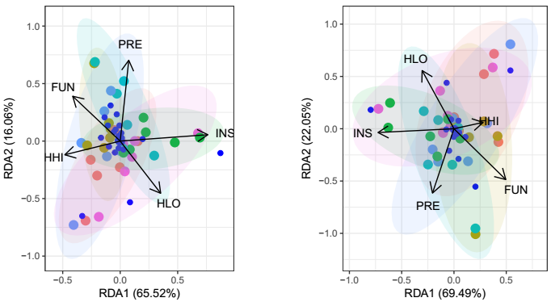

Figure 2. Redundancy analysis of the plant biomass data, conditioned on their blocks. Results for the whole community (A) and woody species (B). [explain percentages meaning, add names for the main species, remove blue dots representing them]

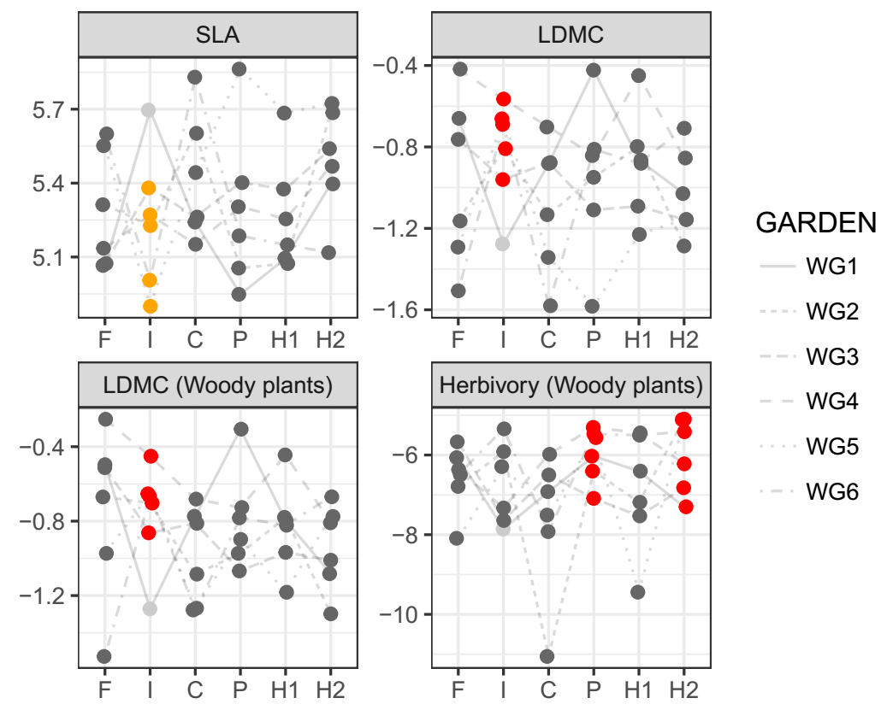Figure 3. Community weighted means of measured leaf traits for the whole community and for the woody plant species. Grey point represents experimental plot overgrown by *Callopogonium mucunoides*., and was excluded from the analyses. Values of CWM LDMC and herbivory are logit transformed, and SLA are log transformed.

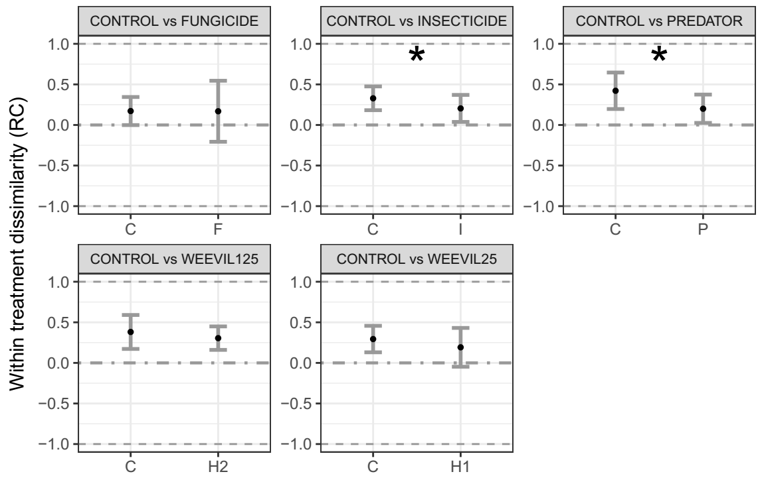

Fig 4. Within treatment dissimilarity (mean ± SE) according to a modified Raup-Crick dissimilarity metric (RC) for the woody plant community (no significant differences were found for the whole community). This metric ranges from -1 to 1, indicating whether a pair of plots are more similar (approaching 1), , or less similar (approaching -1) than expected by chance. Dashed horizontal line denotes a stochastic community assembly. Asterisks denote significant differences between treatments (P<0.05). The whole plant community including also herbaceous vegetation and grasses are shown in the Supplementary Information.

|  |  |  |  |  |  |  |
| --- | --- | --- | --- | --- | --- | --- |
| Index | Average | F | I | P | H1 | H2 |
| LN Bimass | Full (4.409) |  |  | *-0.474* |  | **-0.956** |
| Tree (4.170) |  |  |  |  | **-1.471** |
| Diversity | Full (1.388) |  | **-0.552** |  | *-0.433* |  |
| Tree (0.834) |  | -*0.404* |  |  |  |
| Richness | Full e^2.806 |  | *-0.293* |  |  |  |
| Tree e^2.026 | -*0.395* |  |  |  |  |
| Evenness | Full (0.5) |  | *-0.160* |  | -*0.149* |  |
| Tree (0.436) |  |  | *0.179* |  |  |
| No. of stems | Tree e^3.169 | **-0.726** |  | **-0.431** |  | **-1.049** |
| CWM SLA | Full (baseline) |  | *-0.281* |  |  |  |
| Tree  (baseline) |  |  |  |  |  |
| CWM LDMC | Full (baseline) |  | **0.380** |  |  |  |
| Tree  (baseline) |  | **0.335** |  |  |  |
| Herbivory | Full (baseline) |  |  |  |  |  |
| Tree  (baseline) |  |  | **1.670** |  | **1.653** |
| Randomness  (RC values) | Full |  |  |  |  |  |
| Tree (0.328, 0422) |  | **-0.125** | **-0.221** |  |  |

Table 1. Effect sizes for the community characteristics under different treatments (F – fungicide, I – insecticide, P – predator exclusion, H1 – low added herbivores, H2 – high added herbivores). Values in bold are significant at alpha = 0.05, values in italics are marginally significant at alpha = 0.1. [add all baseline average values] Explain CWM SLA, CWM LDMC